Recruitment In Britain For World War 1

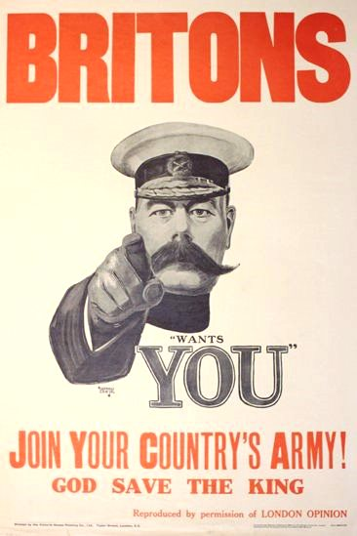

On 7th August, 1914, Lord Kitchener, the war minister, immediately began a recruiting campaign by calling for men aged between 19 and 30 to join the British Army. At first this was very successful with an average of 33,000 men joining every day. Three weeks later Kitchener raised the recruiting age to 35 and by the middle of September over 500,000 men had volunteered their services. His famous pointing poster ‘Your Country Needs you’ first appeared in September 1914, by which time voluntary enlistments had already passed their peak, so the effectiveness of this particular poster was a bit of a myth really. There were as many as 200 recruitment posters designed and created to encourage enlistment. The posters have an increasingly menacing tone in the months before compulsory conscription was introduced in 1916 after Britain had suffered so many losses on the Western Front.

The recruiters uncovered a dismaying fact — almost two in every five volunteers were entirely unsuitable for military service on the grounds of health.

Though 2,466,719 men joined the British army voluntarily between August 1914 and December 1915, even this enormous total was insufficient to maintain the BEF at a strength which would enable it to fight a modern industrialised war involving mass conscript armies.

Voluntary recruitment was drying up
In spring 1915 enlistments had averaged 100,000 men per month, but this could not be sustained. The upper age limit was raised from 38 to 40 in May 1915 in an effort to keep the numbers up, but it had became clear that voluntary recruitment was not going to provide the numbers of men required. The government passed the National Registration Act on 15 July 1915 as a step towards stimulating recruitment and to discover how many men between the ages of 15 and 65 were engaged in each trade. All those in this age range who were not already in the military were obliged to register, giving details of their employment details. The results of this census became available by mid-September 1915 : it showed there were almost 5 million males of military age who were not in the forces, of which 1.6m were in the "starred" (protected, high or scarce skill) jobs.

They were targeted in a number of ways. The skills of advertising were brought to bear with posters, public meetings, tales of German atrocities, and the threat of shame.

On 11 October 1915 Lord Derby was appointed Director-General of Recruiting. He brought forward a programme five days later, often called the Derby Scheme although its official title was the Group Scheme, for raising the numbers. Men aged 18 to 40 were informed that under the scheme they could continue to enlist voluntarily or attest with an obligation to come if called up later on. The War Office notified the public that voluntary enlistment would soon cease and that the last day of registration would be 15 December 1915The 'Derby Scheme' used door-to-door visits to gather men to 'attest' to serve if needed, with a promise that bachelors would be called up before married men.

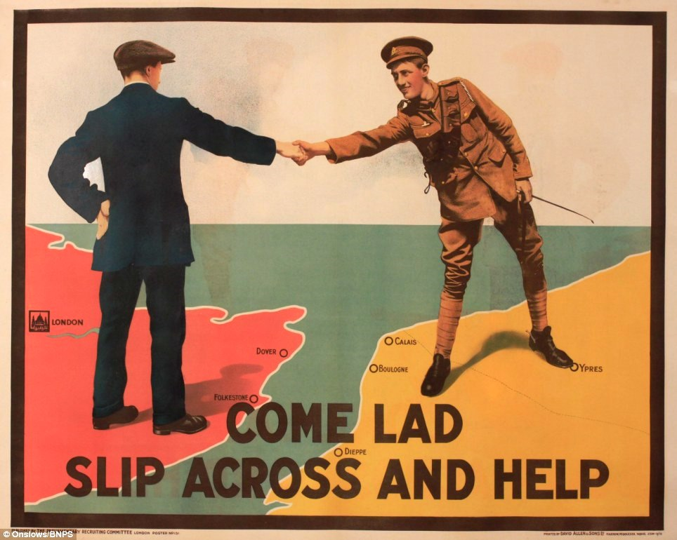

On 27 January 1916, the first Military Service Act introduced conscription for single men of military age, this being extended to married men by a second Military Service Act on 25 May 1916

At the beginning of the war the army had strict specifications about who could become soldiers. Men joining the army had to be at least 5ft 6in tall and a chest measurement of 35 inches. By May 1915 soldiers only had to be 5ft 3in and the age limit was raised to 40. In July the army agreed to the formation of 'Bantam' battalions, composed of men between 5ft and 5ft 3in in height.

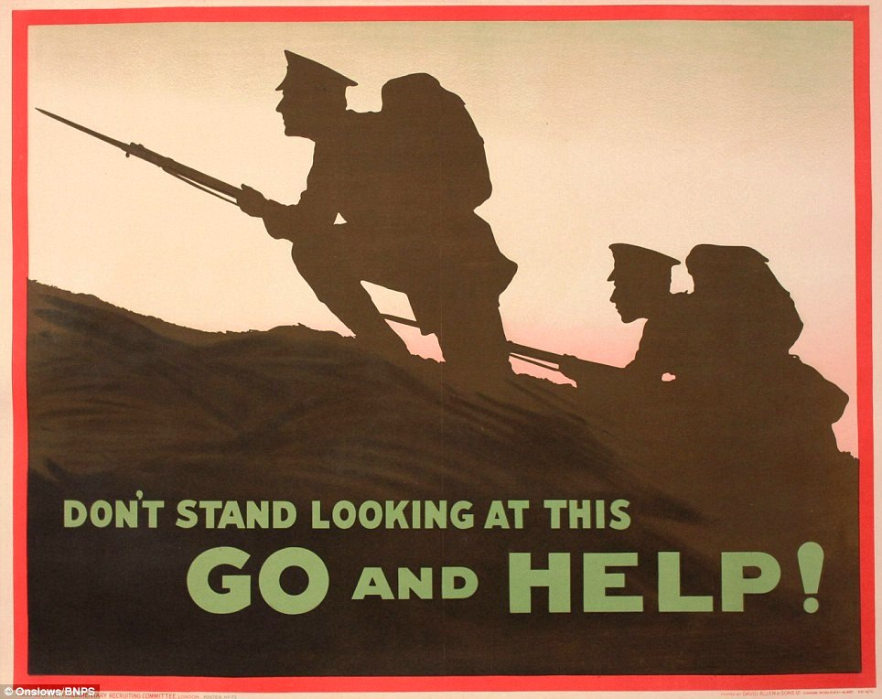

Many public institutions of all sorts mobilized to help recruit for the war. The women's suffrage movement was sharply divided, the slight majority becoming very enthusiastic patriots and asking their members to give white feathers (the sign of the coward) in the streets to men who appeared to be of military age to shame them into service. After assaults became prevalent the Silver War Badge was issued to men who were not eligible or discharged.
The posters increasingly played on ‘guilt’ in the months before compulsory conscription was introduced in 1916 after Britain had suffered so many losses on the Western Front.
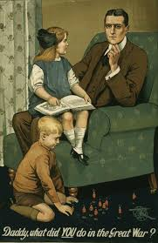

MORE POSTERS

